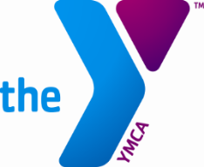
POSITION:
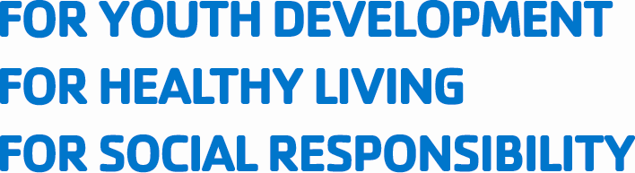
Outdoor Education Program Coordinator
2019 Season · Spring · Summer · Fall
Burgess Outdoor Education & Retreat Center
YMCA Camp Burgess & Hayward · Sandwich, MA

Come join our fun and supportive community at Burgess Outdoor Education & Retreat Center, a YMCA facility located a short drive from the ocean on beautiful Cape Cod, Massachusetts. Our forested property is situated on over 300 acres which include three freshwater ponds, two state-of-the-art high ropes courses, a low ropes teambuilding course, climbing tower, educational farm, recreational waterfront, hiking trails, and dining and overnight facilities. We seek to instill wonder, encourage stewardship, and cultivate community through interactive outdoor experiences with our guests.

This position is a leadership opportunity for a seasoned outdoor educator looking to facilitate other educators in leading meaningful programming for a wide range of youth and adult groups over a consecutive eight month period.

SPRING JOB DUTIES:
- Lead daily logistics for outdoor education and retreat program (including weekends)
- Facilitate guru team meetings
- Serve as the primary liaison between gurus and group leaders
- Support gurus with behavioral intervention as needed
- Support Outdoor Education Director (OED) in training gurus in educational topics
- Teach experiential outdoor programs to overnight youth groups
- Facilitate the safe use of our waterfront
- Be fully trained and capable of facilitating all high ropes positions at Challenge Course Facilitator (CCF) level
- Support Challenge Course Manager (CCM) in training gurus on the high ropes course, zip line, and climbing tower
- Serve as the on call director when OED or CCM is not present

SUMMER JOB DUTIES:
- Support CCM in training Outdoor Pursuit (OP) Directors
- Facilitate the high ropes course for Camp Burgess & Hayward campers at CCF level
- Serve as the on call director when CCM is not present

FALL JOB DUTIES:
- Lead daily logistics for outdoor education and retreat program (including weekends)
- Facilitate guru team meetings
- Serve as the primary liaison between gurus and group leaders
- Facilitate the safe use of our waterfront
- Support Outdoor Education Director (OED) in training gurus in educational topics
- Facilitate teambuilding programming for middle school, high school, and college students through use of our varied adventure education options
- Support CCM in training OE gurus on challenge course
- Facilitate high ropes for school and retreat groups at the CCF level
- Serve as the on call director when OED or CCM is not present
- Support gurus with behavioral intervention as needed
- Support grounds and facilities maintenance.

QUALIFICATIONS:
- Passion for working outdoors with youth, teens, and adults
- Desire to lead educators in safe, efficient, and impactful facilitation of environmental, teambuilding, and challenge course programs
- 21+ years old with a degree in a relevant area, or equivalent life experience
- American Red Cross Lifeguard with Waterfront Module/AED/1st Aid/CPR certification or willingness to obtain at own expense; must be current throughout employment
- Ability to speak clearly and audibly in front of large audiences
- Ability to provide friendly and helpful customer service to all of our guests
- Ability to live + work as a positive team-player in a collaborative residential setting
- Capacity to give and receive feedback on a regular basis
- Physical ability to spend long, active hours outdoors in all elements, safely facilitating others
- Previous experience at Burgess Outdoor Education and Retreats program preferred

DURATION:
- Start Date: tentatively Monday March 11, 2019
- Spring ends: Saturday 6/08 / Summer ends: Friday 8/16 / Fall ends: Saturday 11/02

HOURS:
Expect to work long but extremely rewarding days outdoors in all elements. Daily hours are tailored to the needs of our guests. You will have two days off for every five days worked.

COMPENSATION:
Pay is $425 per week. We provide comfortable staff housing, all of your meals while working, kitchen access, and laundry facilities. Internet is also available. You will have the dedicated support and guidance of our experienced full-time staff. Additionally, Cape Cod is an awesome place to live! You will have access to a wide range of outdoor recreation equipment to help you enjoy it.

APPLICATION PROCEDURE:
Paper airplanes and carrier pigeons can be sent to N41.41.896, W070.27.261 or you can email a resume with cover letter to: ksadoff@ssymca.org

CONTACT INFORMATION:
Kerri Sadoff
Outdoor Education Director
Burgess Outdoor Education & Retreat Center
75 Stowe Road
Sandwich, MA 02563

